1. What's the difference between docker ps and docker ps -a?

When we run docker ps, it will list all the containers which are currently running whereas docker ps –a will list all the containers irrespective of it’s state (running/stopped etc)

1. Why are Alpine and BusyBox images so small?

Because they don’t have a full OS. It includes only core libraries. Also, they share resources with the host kernel.

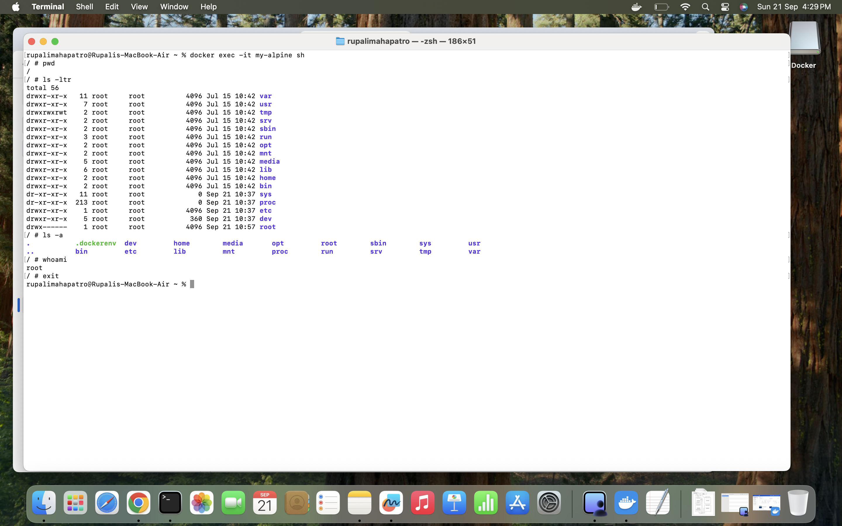



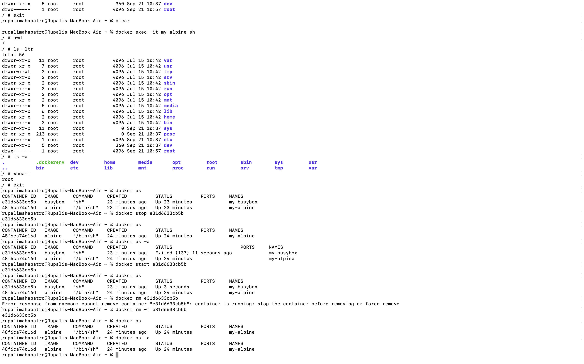

5. 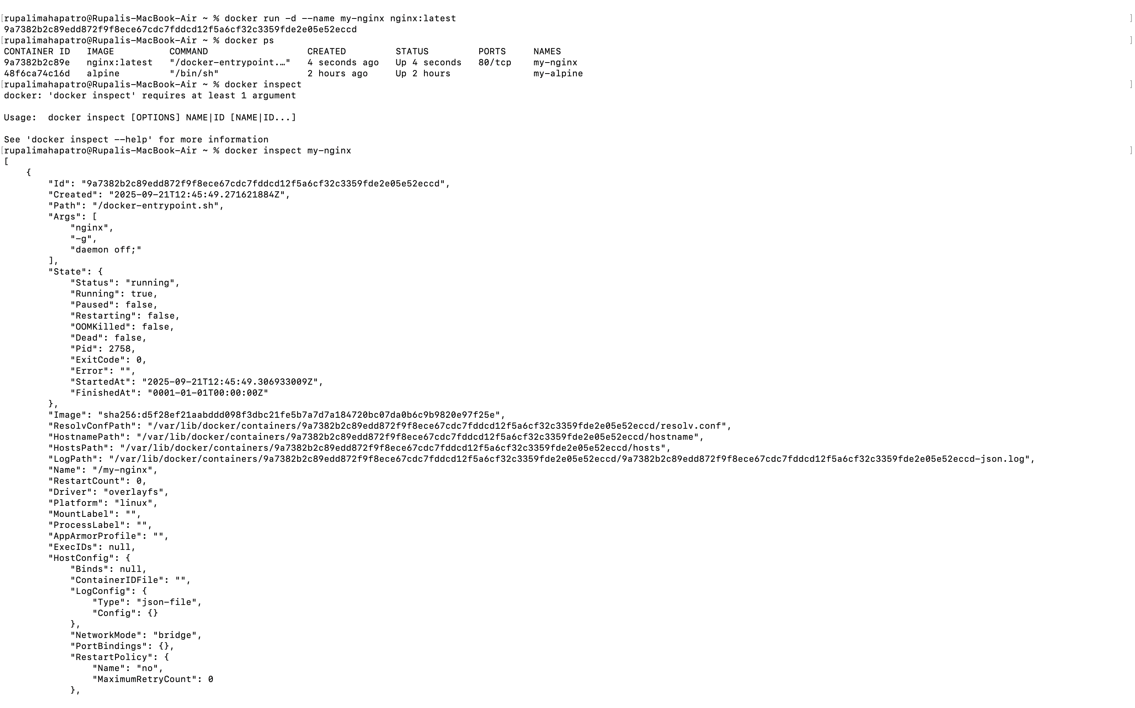

6. 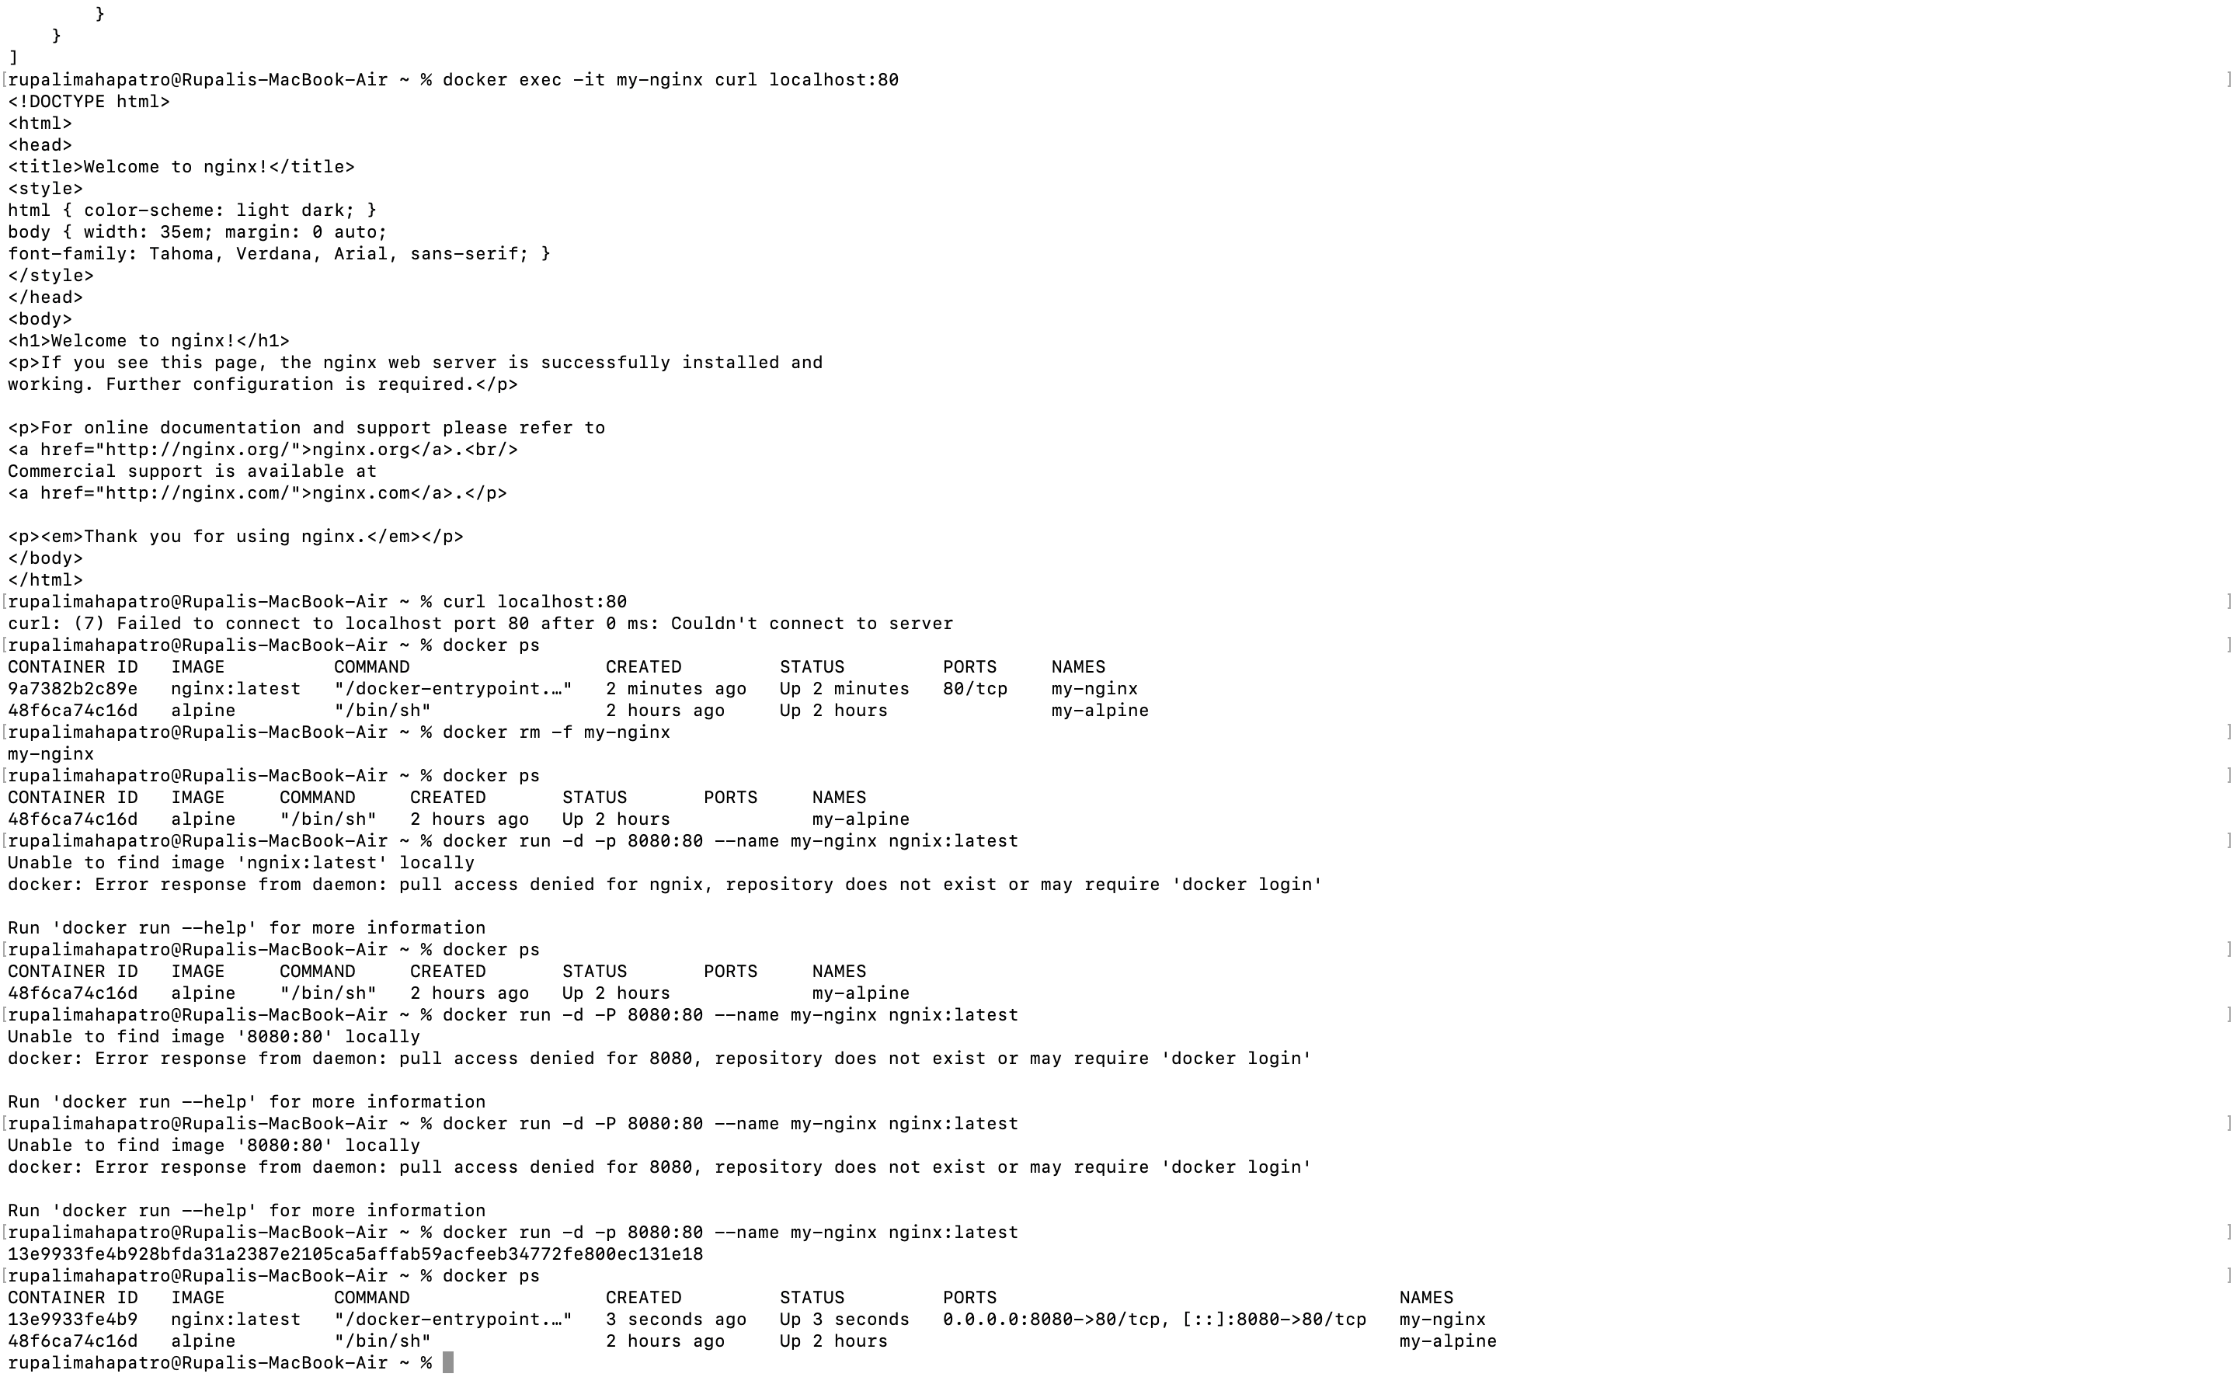

7. 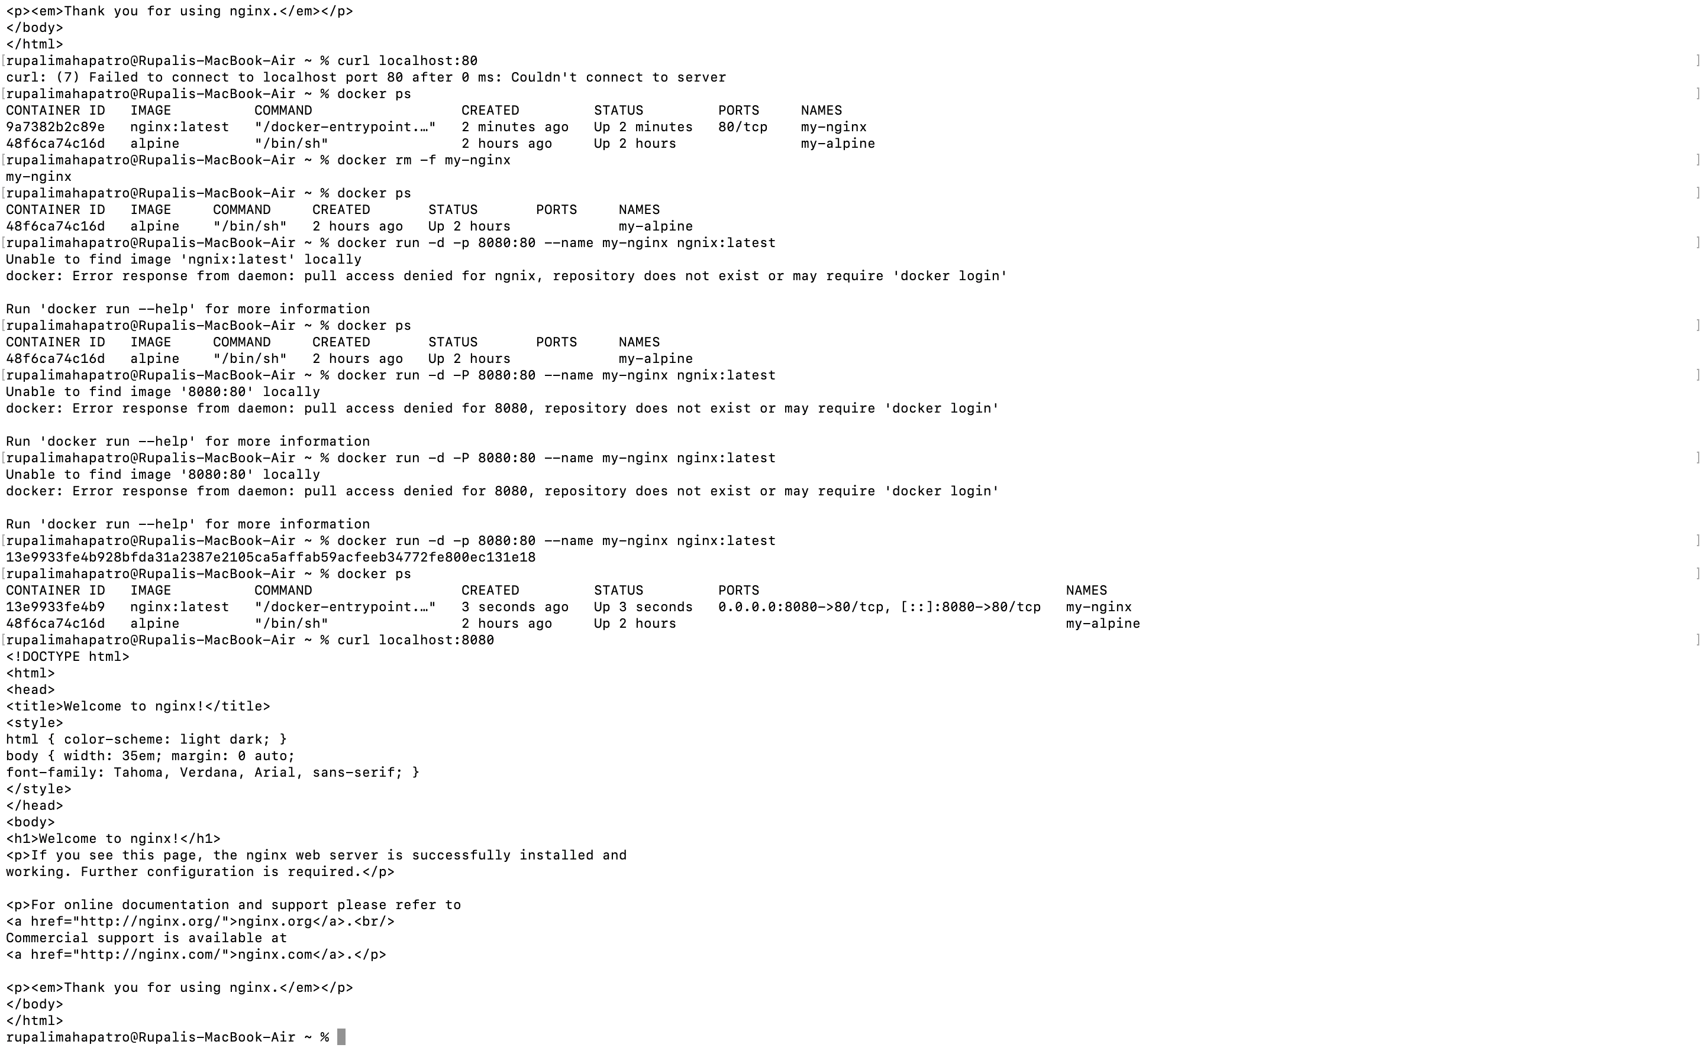

8. 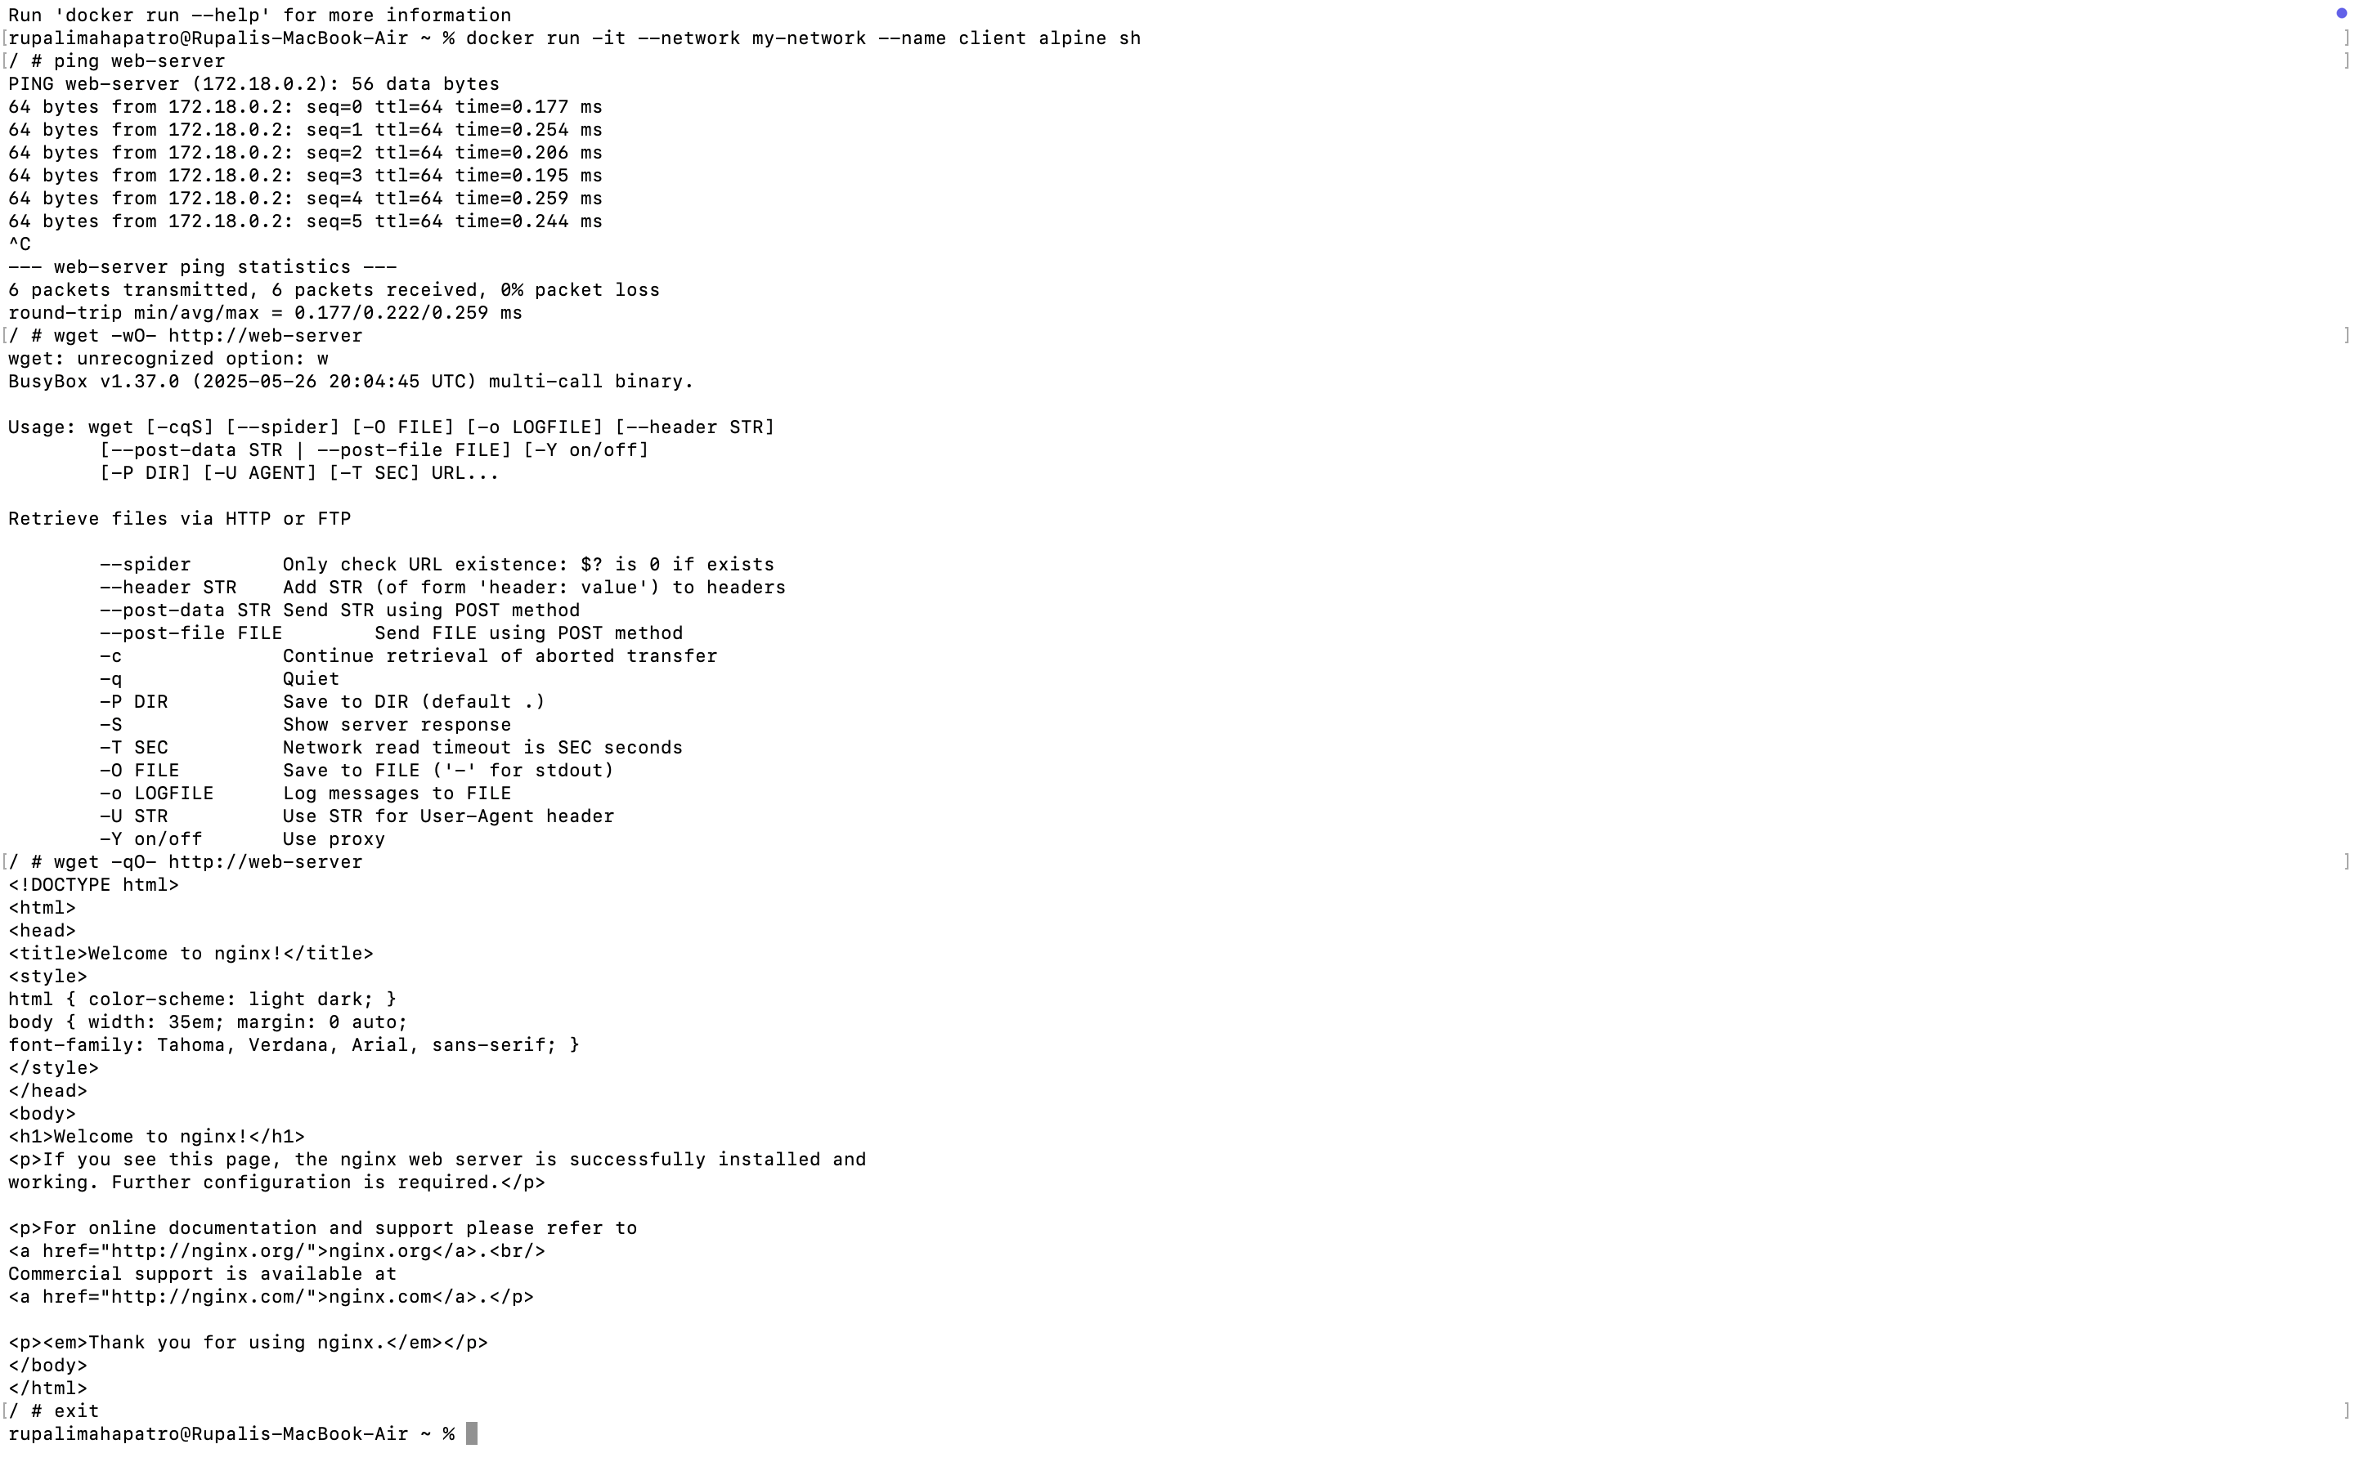

9. Why can containers ping each other by name in custom networks but not in the default bridge?

10. What happens when you try to access the web server from your host machine in the custom network?

Containers in a user-defined bridge are not exposed to the host. So, when we tried curl localhost:80 – it failed because port 80 inside the container isn’t exposed to the host.

11.

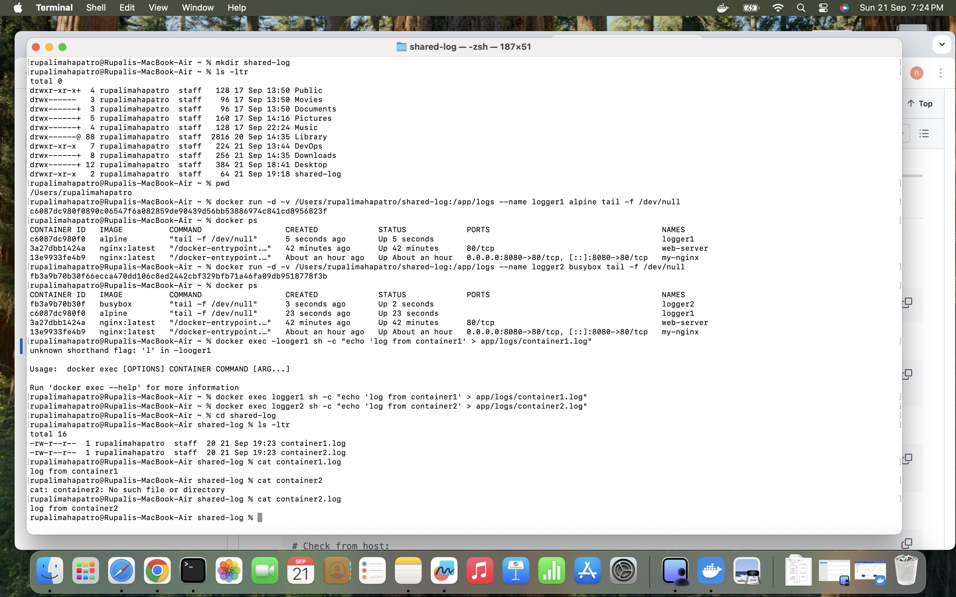

12.

